Name Social Studies; Ch.3 Ancient Israel, Doc.

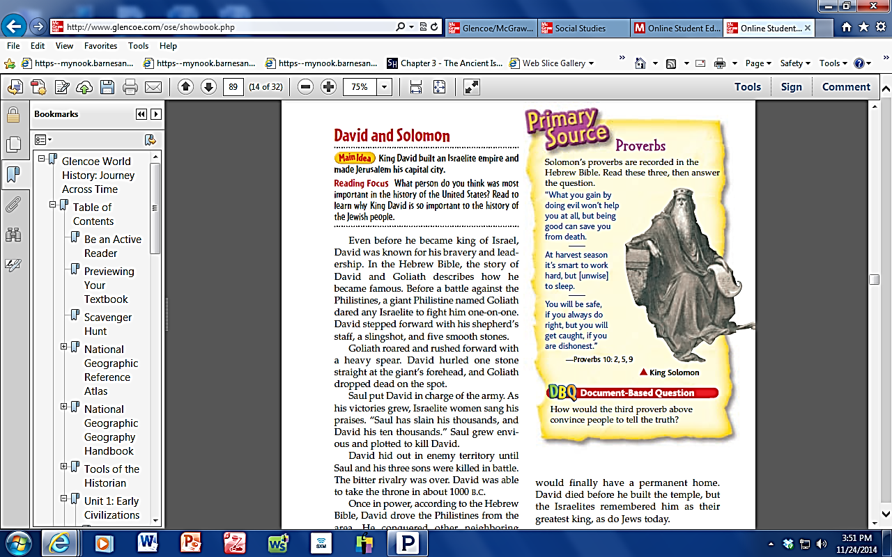Date *Journey Across Time*, p90 Reading Check



